69th Annual Celebration!
2023 KOOSKIA DAYS
THURSDAY JULY 27TH
FARMER’S MARKET-10am-2pm-Kooskia City Park
Family Movie night
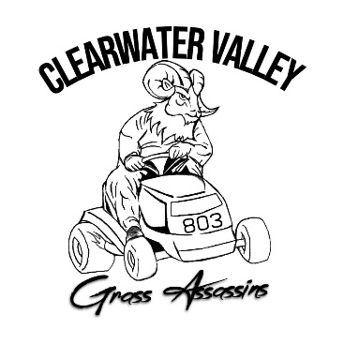
Showing: The PAGEMASTER-9pm-Kooskia City Park
Drinks and popcorn available to buy. Bring your chairs and blankets!
FRIDAY JULY 28TH
LAWN MOWER RACES
To be held at the north end of the airport. Sign-ups start at 5pm, Races start at 6pm. There will be food and drinks for sale nearby. PRIZES!!! Contact William Zarnik 208-935-5672, or Gary Payton 208-371-9261.

SATURDAY JULY 29TH
Fun Run - Benefitting the CVHS Volleyball program. $20 entry fee. Sign-ups are at 7am, run starts at 7:30. Contact Kamm Mangun at 208-451-6243.
PING PONG BALL DROP – Drop is at the Kooskia Airport at 8:30am SHARP!
Sponsored by: Kooskia Chamber, St. Mary’s Hospital, Dale’s Sporting Goods, and Clearwater Valley Aero Club.
PARADE – Sign-ups at CVE 8:30-9:30, judging at 9:45, parade starts at 10:00 am. Contact…
Grand Marshalls: Don and Patty Coffman
National Anthem: Michelle Gonzales
HORSESHOES – Sign-up after the parade, competition begins at 12:00pm.
Singles: 1st Place - $75.00 Doubles: 1st Place - $200/winning pair
2nd Place - $50.00 2nd Place - $100/winning pair
3rd Place - $25.00 3rd Place - $50.00/winning pair
LIVE AUCTION – 5:00pm at the City Park baseball field. Auction includes but certainly not limited to: Red Fir Firewood, Load of Gravel, Homemade Pies and Cupcakes, Certificate for Cut & Wrap (deer), Hand Turned Burl Bowl, Beach Gear, Yard Yahtzee, Custom End-table, Handmade Necklaces, Steelhead Fishing Trip for 2, and so much more.

Old Fashioned Logging Competition – sign-ups start at 4pm, competition begins at 6:00pm. Entry fees: $10/per event. Contact Ashley Walker 208-935-5837
Events: Power Saw Open Class, Axe Throw, Sharp Chain Saw, Choker Set, Jack & Jill Cross-cut, Head-to-Head Power Saw, Wrapper Throw, 3 Man Relay (combination of choker set, axe throw, and power saw)
Prizes: award plaques, $cash$, throwing axe set, camp chef, specialty jerky packs, outdoor bluetooth speaker, damascus pocket knife, chain saw, and endless bragging rights.
STREET DANCE - LIVE BAND 9PM-1AM
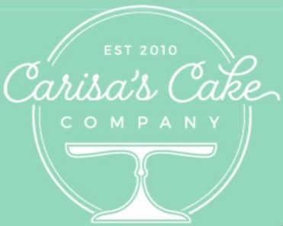
“BROTHERS GRIMM”
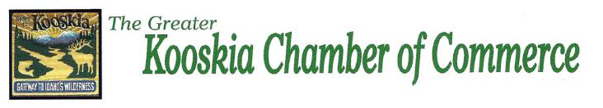

ADDITIONAL SPONSORS: Tom Cat Sporting Goods, , CB Tires, Michelle Fabbi, Bailey Schuster, Cloninger’s/CV Marketplace, Tony Crocker, Vista Outdoors, Jada Schilling,
ALL VENDORS MUST CONTACT THE KOOSKIA CHAMBER OF COMMERCE VIA MESSENGER OR BY PHONE 208-935-5837

